April 2018 Newsletter
This month our main focus is teaching children about Reduce, Reuse and Recycle. Spring is here. It’s time to look in your child’s cubby to change children’s clothing for spring time weather. Please label all belongings. We strongly encourage children to be here by 9:00am to start the day. If your child has a fever he cannot return to school until he/she is fever free for 24 hours. As Spring has approach it’s that time of year for Bug and Sun Screens. This year we are getting Babyganics Mineral SunScreen SPF 50w/ Insect Repellent for the cost to parents at $2.00 covers all Spring and Summer limits all the chemical odors in the center
Author of the Month: Wood's first memories of storytelling were in Sarasota, Florida, where her father was employed by Ringling Brothers Circus, commissioned to repaint the big top and sideshow murals. As Audrey became friends with the characters of the circus, she heard stories about them from the family of "little people" who lived next door to her family. She was the first of three girls. As the oldest, she began her gift of storytelling with her younger sisters. She would use her parents' art books and make up stories about the paintings. By the time she was in fourth grade, her ambition was to become an author/illustrator.
Wood uses the medium of children's literature to practice the disciplines of art, music, drama, dance, and writing. Her unique work creates a sense of imagination and excitement. Audrey loves step-and-repeat stories for the "music of language". An example of this would be her famous book, The Napping House.
Her husband Don Wood is the illustrator of many of her books. They began collaborating on children's literature seven years after their marriage, their first book together entitled Moonflute. Since the publication of Moonflute, Don has illustrated nearly 20 of her books. Their son Bruce Robert Wood is also an illustrator, which makes art a fifth-generation tradition in the family.

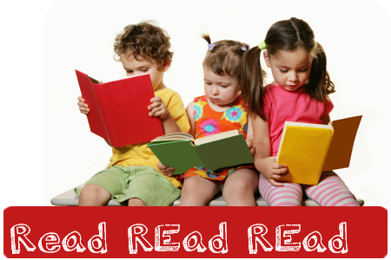
Importance of Early Childhood Reading/Education
Children are constantly learning, right from birth. The experiences they have daily help to shape a foundation for their mental development and growth for years to come. This is our greatest opportunity and our greatest weakness. Reading with young children is an easy way to connect with them and teach them invaluable words and language skills. Books with pictures and age-appropriate words hold a young child's attention, and adding sound effects of funny voices can make reading time even more special. Developing reading skills at an early age exposes children to words, ideas and text before entering public school.

School News
- Patriots Day Closed on the 16th
- Hop-A-thon @215
- Arbor Day Plant a Tree on 27th
- Progress Reports are in process now, if you would like to have a conference with your child teacher in May.
- Toddlers 7th
- Preschool 14th
- Pre-K 21st
- Signup sheet will be posted to save your spot 4-530pm

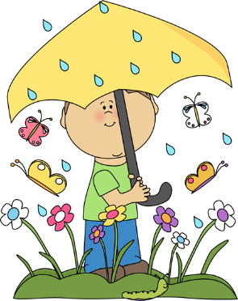 | April 2017
 | Spring Celebration

Sun. | Mon. | Tue. | Wed. | Thu. | Fri. | Sat.
1 | 2 | 3 | 4 | 5 | 6 | 7
8 | 9 | 10 | 11 | 12 | 13 | 14
ALL ABOUT ME
Show & Tell
Preschool and Prek
15 | 16 | 17 | 18 | 19 | 20 | 21
 | Closed!!  Patriots Day |  |  |  | Hop A Thon  @ 2:15 Ice Cream
22 | 23 | 24 | 25 | 26 | 27 | 28
Earth day  Hop a thon week |  |  |  | Group Activity: Recycle Art | Arbor Day: Plant A Tree  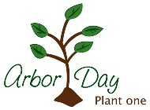
29 | 30 | 1 | 2 | 3 | 4 | 5
Recycle week |  | Wear Yellow Day

notes | Author of the Month: Audrey Wood Numbers of the Month: 14 & 15  Color of the Month: Purple, Yellow Shape of the Month: Triangle, Circle  Letters of the Month: Gg & Bb

